**HW Assignment 2**

**Organization, Processes, Information systems, and BPR**

16102284 Lee SungHo

**1.Write a cover letter for the assignment summarizing the most conspicuous findings and explaining the process behind your research. (one page)**

We tried to figure out the business process of Paris baguette. We loved the bread and visited Paris baguette many times. So, we could find the store fail to predict the customers demand from the amounts of leftovers in late time. And the delivery van arrived several times in a day. We thought the process of ordering and distribution has some problems. W investigated the business process of the Paris baguette focused on the ordering and distribution.

Paris baguette use POS system and SAP-ERP in information system. POS system enable the company to manage the amount of the inventory and sales. ERP integrates the functional area of the company (integrated information system).

In the distribution process, the process was repeated twice because the method to store the bread and dough is different. Paris baguette select the bake-off sysAnd the dough should pass additional process in the store also. These proces need the special equipment and specialists. Of course, these need some cost and time. We try to figure out the solution.

Also, there is no prediction system or guidelines for the amount of oreder. The amount of the bread to sell is decided by the shop owners’ feeling and experience. It may not fit with the real demand of the customers. Some kinds of the bread remain, and others are scarce. To maximize the profit, we need to predict the customers’ demand better.

We decided to change the process between the middle distribution centers and the shops. We re-arranged the business process of the store into middle distribution centers. Originally, when the dough is arrived the store, it is frozen. Then, the specialists thaw and make the dough fermented again. We plamned this distribution center do this process and enable store to get the perfectly-fermented dough. We expect this can decrease the flow time of the distribution and cost. It can help the stores to reduce the time and cost to prepare the bread also.

The other solution is adding an additional function to existing information system. There is no prediction system.

Using the POS system, the company can collect the data of sales, inventory and analyze the trends of customers. The stores can decide the amount of order from the company’s prediction. And it help to maximize the stores’ profit. In the case of the company, the data help to plan new business or products.

We searched the information in internet. We visited the website and send e-mail to the company. We also interviewed the part-time job employees, the owners of the stores and the headquarter of the Paris baguette. Some information of deep process is regarded as secret. So, we have some difficulty in research. But we supplement the data from interview and Internet. It was difficult to find a problem in their process because the Paris baguette is already major company. The business process was thorough. We tried to do our best. So, we wish our result fit professor’s demand.

**2. Describe the company, its products, and its industry. (half page)**

This company was established in 1986. The company have the headquarter-directly managed bakery (Paris Croissant) and the bakery franchise (Paris Baguette) which is subsidiary of SPC group. Paris Baguette has about 3,400 shops in Korea and 400 shops abroad. Paris Baguette reflected the intention of franchise stores as much as possible, chose to grow its base in the Seoul metropolitan area, and dominated the market through differentiated processes. Now Paris Baguette is the best and greatest bakery brand in Korea.

Currently, the domestic bakery industry is divided between SPC Group's Paris Baguette and Tous Les Jours. The two companies hold 96 percent of the market. Among them, Paris Baguette is the dominant player in the industry with 69 percent of the market share. Mindful of this monopoly, the government has imposed a 2% year-on-year limit on "Paris Baguette" since 2013. In addition, if the distance from nearby small and medium-sized bakeries is within 500 meters of walking distance, they will not be allowed to open stores.

So SPC Group, whose growth engine has been blocked, expanded its activities to the United States, Singapore, Vietnam and France after launching Paris Baguette into Shanghai, China in 2004. As of 2017, SPC Group posted about 6 trillion won in sales. Of the total, sales at overseas subsidiaries are about 6 percent, or about 336.6 billion won, and are continuing to expand aggressively.

**3. Describe the organizational structure and information systems. (half page)**

After inquiring with the customer center of the headquarters, unfortunately, we can’t find Paris Baguette's organizational structure and CIO, because Paris Baguette don’t open structure. So we introduced the structure of ‘SPC Samlip’, a company under the same SPC Group.

PB has thousands of franchise stores and it also produces hundreds of products. To reduce franchise stores shopkeeper’s burden, headquarter bear the most of expenses from returned inventories. Because of this, information system could minimize losses. The headquarter have to know how much each store has sold and how many items each store has left in the inventory, and this information can reduce inefficient orders.

Also the company can run delivery system wisely. PB tries to manage the stores & the products effectively by adopting web-POS and ERP system. PB needs to get both customer’s satisfaction and business efficiency. Therefore, standardized and organized systems which can deal with plenty of stores and products at the same time are adopted.

Company has to develop new system managing customer effectively. SPC group which is the parent company of PB also has many subsidiary companies. If PB could use database integrating whole SPC groups’ customers, PB could get much higher competitive advantage in their bakery industry. So, PB and SPC group introduced Happy Point card in terms of one of CRM activities.

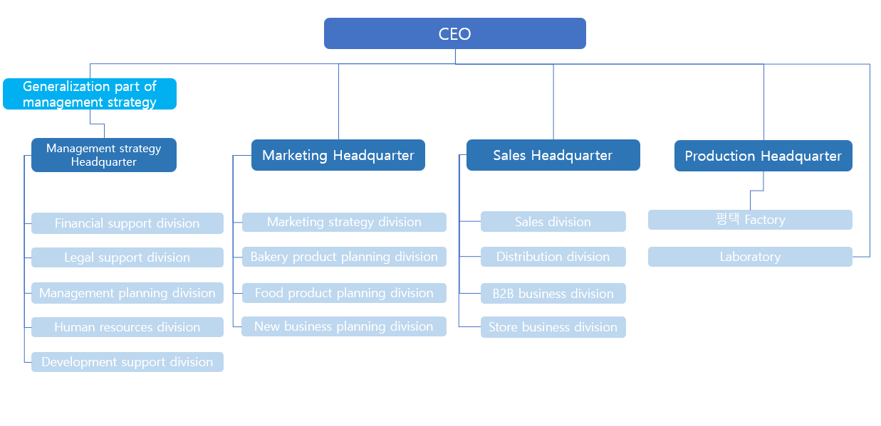

**4. Describe the role of CIO and IT department in the organization. (half page)**

IT department use SAP ERP system and integrate a whole part for business management. Whereas information technology integrates with the core business processes to achieve certain business objectives, using ERP can combination of the three most important components; business management practices, specific business objectives, and information technology.

As this integration, it can efficiently control all tasks related to company funds, finance, sales, production, and acts as strategic tool to supplement what they overlook. And it allows for the whole company to have access to all necessary information, thus all remaining up-to-date and running together. And it contributes significantly by reducing the production time, and inventory accuracy, thus effectively handling procurements.

And IT structure also use POS system, this system adopts barcode system or OCR (Optical Character Reader) tag; therefore stores using POS can record information about the sold product immediately and sent it to main computer. By using this system, it helps to analyze and get various kinds of information like inventory or trend of the market. Also it makes it easier to manage lots of franchise stores.

‘Happy Point card’, which is maximizing benefit to SPC group’s customers by combining Data base among SPC’s subsidiaries, is the most popular point saving card with 19 million members in 2017. Paris Baguette actualizes data base marketing effectively by Happy Point card. Data base marketing, also called one-to-one marketing, analyzes customer’s tendency and establishes efficient selling strategy with information like which customer buys what product and how frequently, in which stores, and when the customer repeats their purchase. Paris Baguette collects, integrates, and manages much more customer’s data through the method that saving all SPC group’s franchises’ point in one card. Integrated data base collected this way makes it easy to understand the market, customer’s needs, and information about potential customers. With this, Paris Baguette increases existing customer’s satisfaction, attracts new customers and establishes stable and long-range relationship with them, so it can remain it’s dominant status in bakery industry.

**5. Pick up one of major business processes and describe it. (one page)**

We will describe the business process of importing raw materials from the SPC affiliate so that bread can be made in each store. First of all, SPC imports raw materials and puts the factory in the head office. For example, it imports flour from one of its affiliates, ‘밀다원’, or film, which is a package of soft-packing or ice cream products and a package of cake cases, which are used in the packaging of bread and bread.

After dressing like this, it goes through a different process depending on the type of bread. The "Bake-off" system, a common bread production method, is a system that manufactures dough during the production process, freezes it at -35 degrees Celsius or below, and supplies each franchise with dough that is frozen to keep the temperature below -18 degrees Celsius, so that it can be baked in the oven at the store and displayed directly on the stand. In other words, the dough is kneaded in the factory to be split and formed. It is a business force that provides it frozen in the store and melts, defrosts, bakes, and sells it. This method has the advantage of reducing the inventory of rework and finished products, simplifying transportation, and maintaining a high factory operating rate, but it has the disadvantage of placing special equipment and professional personnel such as fermentation rooms in each store and increasing material prices.

Another production process is 'Par-baking'. The method is to bake half of the products that have been announced and quickly freeze them so that they can be processed at stores. It is suitable for French breads such as Musketeers and Donuts, whose ‘Best Before Date’ is the most delicious period to eat.

Products made with these two methods are delivered to each store using 'Digital Picking System'. It transmits the forwarding information from the ‘head-quarter’ through the ERP system and turns the flashing light on the indicator. This process refers to the process of packing the product, inspecting it, and releasing it to each store. Use a 'cool pack box' to prevent the frozen products from melting in the process. After inserting frozen products inside the "Cool Pack Box," it injects liquefied carbon dioxide and delivers it up to two times a day to each merchant.

Each store then receives the pre-ordered items and sells the bread to consumers through processes such as defrosting, presentation, and baking. When all the bread is sold out, the owners of each franchise store either look at the sales data or use their previous experience to decide how much they want to order " dough " and inform the head office.

**6. Describe the relationship between all functional areas and the process. (half page)**

All that was described earlier is possible with the introduction of the SAP ERP system. All processes such as production and distribution were registered in the ERP system, enabling inventory management, merchant management, accounting, and human resource management.

ERP used in Paris Baguette is web-based ERP which is made by SAP Corporation, therefore data saved through ERP is managed on the internet, not on the computer of each stores. Managers can use diverse service provided by UPS after simple user certification.

Main functions of Paris Baguette’s ERP are composed of self-service that enables to realize user-familiar interface, analysis about manage, labor force, and financial, accounting, management of human resource, and enterprise service. Managers of each store can administer not only lots of store’s data and also company’s data with this ERP program since it is interconnected with headquarter.

To mention detail of the effects of ERP to PB, it helped to maintain products’ freshness, and allowed for easy management of franchises, thus increasing the number of stores noticeably. With ERP, PB was able to standardize the process from procurement, delivery to final sales, thereby decreasing the unnecessary inventory, acting flexibly to sales and improving production process.

By managing each separate franchise chains, the increasing number of stores was not a problem, since there is a combined set of information technology ground which provides systematic information. Once all the relevant information system is set, then dealing with multiples of stores did not become a problem.

**7. Analyze activities involved in the process and kinds of data needed by the process (as-is analysis). Any problems? (two pages)**

**Bake-off system**

Paris baguette select Bake-ff system for the way of providing the dough to their franchise stores.

It means the dough factory provide the frozen half-fermented dough to their stores for some kinds of bread. The frozen dough suffers the processes: Fermentation, Molding, Freezing and distribution of the dough. And the others are provided in perfectly baked status. In stores, the specialists proceed the remaining process for the frozen dough. For example, thaw, fermentation, bake the dough to sell the bread.

**Advantage**

Decrease the inventory of perfectly baked bread

- The factory provides the half of the breads in frozen dough instead of baking all the breads. So, the factory can reduce the cost of processing the perfectly baked breads’ inventory.

Easy to distribute the bread

- The perfectly baked bread is difficult to store and keep the freshness. And it also takes up the great capacity because of the packing. But if the company provide the frozen half-fermented dough instead of perfectly baked bread, the store can provide the freshly baked and the company can also distribute more product to each store.

Flexibility of the product

- When the store gets the dough in frozen, they can re-mold the dough and choose what breads they sell to their customer. However, if when the breads are delivered in perfectly baked, they cannot plan their sales.

**Disadvantage**

When the stores bake the dough, they need to thaw and make a dough fermented additionally

- The frozen dough did not go through perfectly fermentation. So, the store should proceed additional processes. During these, the time and cost occurs. Also, the special equipment like fermentation room and specialists must be prepared in the stores.

It is difficult to guarantee the quality of the finished product

- The stores sell the half of the breads delivered from factory and others fermented and baked in stores. The shape or quality of the breads perfectly baked in the factory are similar. However, in case of the breads fermented and baked in stores, the quality can be different according to the stores. It can affect the brand’s image badly.

**Ordering**

The owners of the stores order the bread and dough to the headquarter of Paris baguette. The amount of the orders is decided based on the owners’ experience and feeling. It has no guidelines from headquarter, so this is the inevitable thing. When the new product arises, the headquarter force the stores which have great sales to order the new product.

**Advantage**

The company can check the customers’ reactions for the new product easily

- When the new product is released, the company should plan a promotion for the new product. However, if the company displays the products in popular stores, the company can check the reaction and data of new product easily without imposing a burden to all the stores.

The company respect the stores’ decision of ordering.

- Excepting some special case, the company do not interfere in the stores’ dough and bread order. It means the company believe and respect the plan that each owner of stores has.

**Disadvantage**

The stores may have lots of inventory.

- The amount of the bread is decided by the shop owners’ feeling and experience. It may not fit with the real demand of the customers. Some kinds of the bread remain, and others are scarce. The owners just reduce the order for the kinds of the bread left, and increase the order for the kinds of popular bread.

The certain stores bear all the burden of the new product release.

- We can find out the fact that the company force some shops that have many customers to sell the new product. If the reaction of the new bread is bad, only the stores must have a burden of the inventory.

**8. Draw a process map for the chosen processing system.**

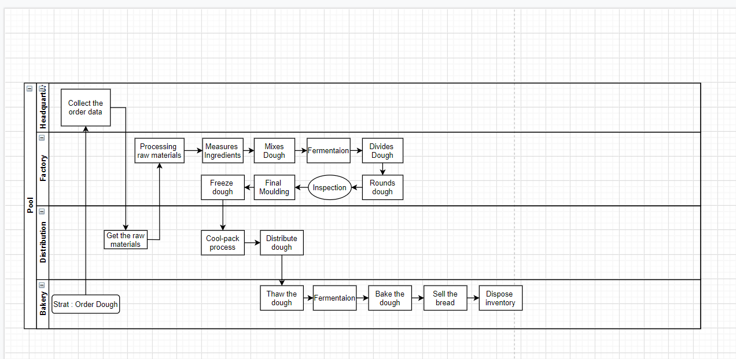

**9. Explain the information systems regarding the process; how well is it being done? Any special features? (if there is no information systems regarding the process, design an appropriate one for the process and explain how the information systems would help to improve the process). (half page)**

As mentioned before, Paris Baguette was the first confectionery company to introduce SAP ERP. As a result, the product's freshness was easier to maintain, the sales and production processes were more flexible, and the franchisees could be easily managed, contributing greatly to the expansion of their power.

Also PB use POS system. As this program, stores can record information about the sold product immediately and sent it to main computer. By using this system, it helps to analyze and get various kinds of information like inventory or trend of the market. Also it makes it easier to manage lots of franchise stores.

As a result, firstly, PB is able to maintain freshness of bread. If some kinds of bread are popular or trendy at each franchise stores, headquarter promptly know that since all information are sent to main computer by POS system. Therefore it can adjust proper level of inventory. Freshness is very important especially in the bakery industry, so this aspect contributes to PB’s success. These data also provide customers with an online ordering system that allows them to deliver or pick up their inventories by using their Happy Point app. And the company is also providing pre-booking service to sell bread to consumers on the same day if they pre-order the bread they want.

Secondly, POS help PB’s extension strategy. It is not easy to manage lots of stores, but POS system help to overcome that kind of difficulties. The headquarter gets the information about each branch’s issues like sales and understands their situation at once, so it also gives an adequate advice to them. This system also helps PB to manage its stores not only in Korea but globally.

**10. What changes in the business process and information systems do you think will improve the chosen processing system? If appropriate, make suggestions for improvement (to-be analysis). (one page)**

After conducting interviews with Paris Baguette Customer Center and current Paris Baguette drivers and part-timers, the current logistics system delivers products made in factories to the middle warehouse. Then, when the shopkeeper orders the ingredients, he or she supplies the ingredients twice a day, depending on the type of ingredients ordered by the warehouse. Baked-already items such as cakes and non-food items such as candles and matches are first supplied to each store at 6 a.m. using refrigerated vehicles. And frozen doughs received using the cool pack system are supplied to each store in the second afternoon. In other words, logistics happens twice because the characteristics of the supplies are different.

Thus, to reduce these inefficient business processes, it is necessary to change them. As an 18-year article suggests, Paris Baguette recently built many warehouses. The way we propose is to use these hub facilities to proceed with thawing and fermentation in the middle. This allows the doughs, which have been completed of secondary fermentation that can be carried through the refrigeration system, to be transported through the refrigeration system, such as baked-already products and non-food products. This will reduce the delivery process from two times a day to one, significantly reducing the delivery process time.

Some processes need to be modified or added to change to this process. First, we need to collect the sundials and ferment machines that were in each store and build them in the headquarters warehouse. And it is necessary to build a system that can predict how many doughs a day, which is the most important process, should be distributed to each branch. These systems can be deployed by introducing POS systems and SAP ERP systems currently in Paris Baguette and AI systems. As mentioned earlier, the POS system and the ERP system produce all the inventory, sales volume, and output. Based on these high-quality, decade-long stacks of data, multiple AI models such as Random Forest, XGB Boost, and RNN will enable a fairly good performance forecast model with good data quality.

Also, one of our problems is that when we go to Paris Baguette in the evening or in the morning, we often sell unsold bread at a discount. This is the unnecessary creation of a large number of breads by misjudging how much they will sell. In order to reduce this inventory, the headquarters should establish forecasting systems at the headquarters level so that store owners can use forecasting systems on how much bread and dough they have to be ordered and sold.

As mentioned earlier, this process can also be predicted on a seasonal basis through a time series analysis like the ARIMA model, with data made from POS systems and ERP systems, including time and space-related columns on when and at what point the materials were shipped and sold at which time. And a regional analysis of the surrounding commercial districts is also possible, proving that it is possible to establish a model that presents fairly accurate results earlier and that these are not necessarily impossible.

**11. Draw a new activity flow for a re-engineered processing system.**

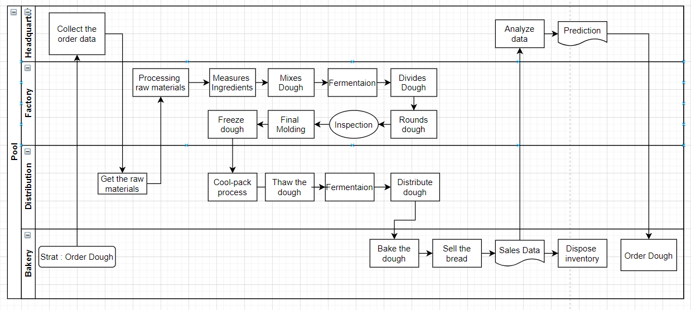

**12. Finally, identify benefits from the improvement in the business process and information systems and determine ROI. (one page)**

There are many benefits of introducing these forecasting systems into the logistics or sales process.

**Manage the inventory of stores efficiently**

Currently, each store in Paris Baguette sells unsold bread at a discount, leaving a small margin, or gives it a donation to Food Bank and receives a subsidy from Paris Baguette company for the donated bread. Therefore, poor inventory management reduces the profit. The introduction of such a system is beneficial at the company level, as it minimizes the number of such inventory cases.

**Increase the success rate of new business and product**

It will have a positive impact on the development of new products or the production of existing products by analyzing customers' bread consumption data. Currently, Paris Baguette is said to sell new products to each branch to cover losses on R & D if the newly developed product does not sell well. This compulsion is, in conclusion, a loss at the company level. Thus, if more accurate trend identification is possible, these losses can be reduced. These forecasting systems will also increase the flexibility of production through sudden variables, or by analyzing the tastes of consumers who have changed. This flexibility will help us manage inventory at the head office level, as well, by enabling inventory management of products produced at the head office.

**Reduce cost(economies of scale)**

The total cost will be reduced as economies of scale work when thawing and fermentation processes are carried out at headquarters. At present, this process was carried out at each store, so there were thawing and fermenting machines at each branch. This process is inefficient, so it would be possible to proceed more efficiently if the process was carried out in an intermediate hub system.

**Reduce cost(labor)**

Labor costs can be reduced. Currently, bakers, who are high-quality workers, are hired at each store and are working on various tasks. They also pay night allowances to go to work early in the morning to carry out various tasks such as fermentation, mold, and production. If bakers replace the process they have to do in the interim process, their work can be reduced, reducing labor costs such as night allowances. Also, since the original two deliveries were reduced to one, it will be possible to hire and manage drivers efficiently, thereby reducing labor costs for them.

**Process time decrease**

Finally, process time can be reduced. As we said earlier, company was able to reduce overall flow time by shortening the logistics process time. This will increase efficient capacity, so it can make additional production to increase revenue, or decrease in cost such as labor costs, thereby increasing the profit.

These forecasting systems cost a great deal of money to introduce an ERP system that organizes the collection of initial data. However, since these data collection systems are now well-established, only the cost of developing the model is currently cost for BPR. In other words, ROI will be evaluated positively because there are many benefits that can be gained at no such high cost.